**Tutorial 45: Conditionally Showing Data**

In the tutorial we are going to make sure that the data displays on the page while the data is being fetched over the server.

Make sure **Tutorial 44** is complete to be able to move on to this tutorial or clone the [vue3-firebase-course](https://github.com/younggrasshopperza/vue3-firebase-course) repository and go to branch called **Tutorial-44** and navigate to the young-grasshopper-jobs folder.

**Step 1:** In the JobDetails.vue file, we want to make sure the information renders onto the page. Inside the template, create a div tag with a v-if condition that takes an argument of the value job. Move the h1 tags and the p tag inside the div tag.

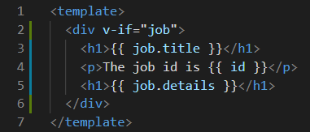

**Output:**

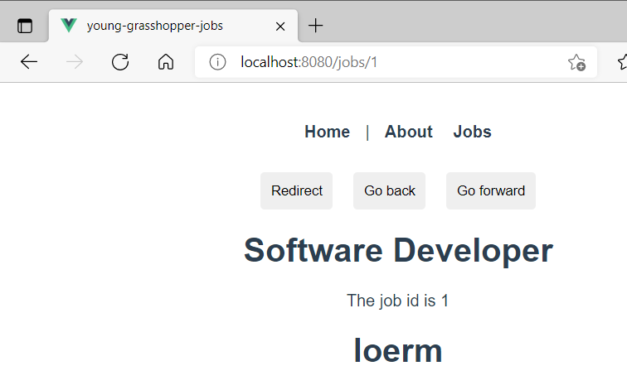

**Step 2:** In the JobDetails.vue file, when the data has not been loaded yet, we would like to display a message to the user. Inside the template tag, create a div tag with a v-else condition. In the div tag create a p tag that displays a message that the data is loading.

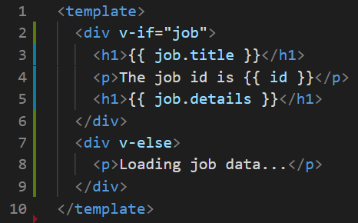

**Step 3:** In the Jobs.vue file, we want to also display the jobs when the data has been fetched. Inside the template tag, under the h1 tag, create a div tag with a v-if that takes an argument of the value jobs array length (**jobs.length**).

Look at the example below (**Between** **line 3 and line 12**):

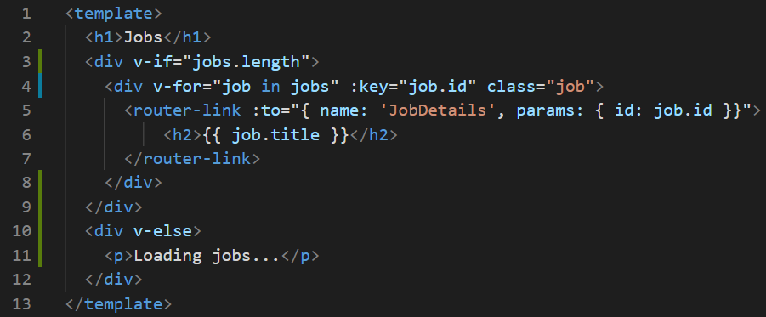

**Output:**

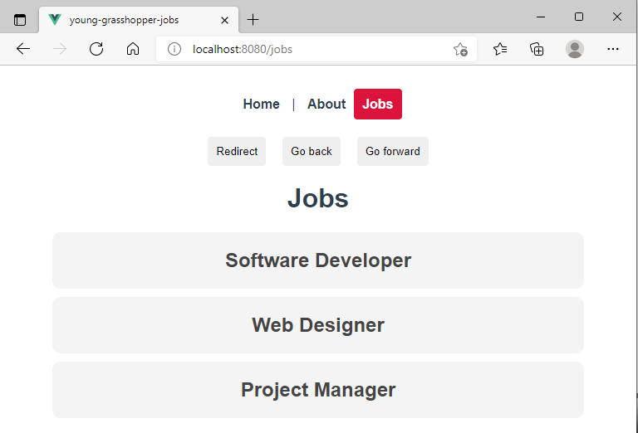

**You can view the code snippets from the** [**vue3-firebase-course**](https://github.com/younggrasshopperza/vue3-firebase-course) **repository under the Tutorial-45 branch**.